Banking App

Making a baking app with the feature of ->

1. Create Account Holder Name & balance
2. Show account holders by id
3. Show all saved account holders
4. Deposit
5. Withdrawal
6. Delete the account

**Work Flow:**

Controller

DB

API

Service

**Program Methodology:**

1. Make a jar file in spring Initializer. Open in IDE. In com.sol.banking package make these following pakages.

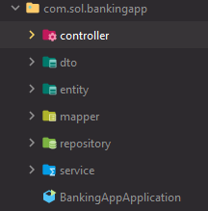using MVC architecture, in model layer we use service package. Entity, dto, repository for story bean var. and controller to connect with api which is the view here.

1. Make a Account Class in Entity. Using following annotations

* *@Getter, @Setter* for auto Generate getter and Setter
* *@NoArgsConstructor, @AllArgsConstructor* to create constructor dependency injection
* *@Entity* for define Entity Class & *@Table(name="accounts")* to create accounts table in DB
* @*Id* – for unique Value key
* *@GeneratedValue*(strategy = *GenerationType*.IDENTITY) -Auto generated Identity key
* *@Column*(name= "account_holder_name") – make thw Coloumn name account holder name

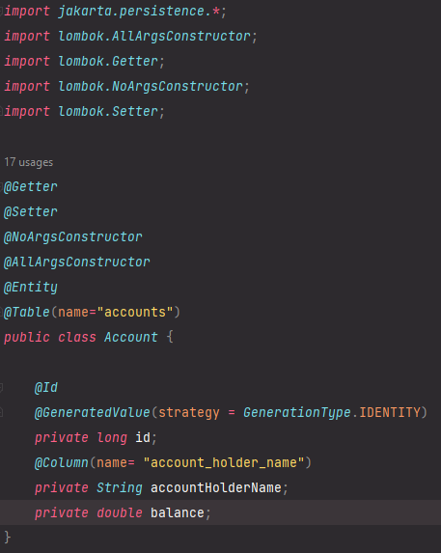save the entity data as an encapsulation , using private access specifier. Then id as a long , accountholdername as string and balance as adouble.

1. now to connect with database, Mysql . in application properties

*spring.datasource.url*=jdbc:mysql://localhost:3306/banking_app  
*spring.datasource.username*=root  
*spring.datasource.password*=Helios2110@  
*spring.jpa.show-sql*=true  
  
*spring.jpa.hibernate.ddl-auto*=update

and create a database in mysql with the name banking_app

1. make a AccountRepository interface in repository fetch or push the data from Database. By Using the JPA repository it connects with entity beans and uses in service layer.

*public interface AccountRepository extends JpaRepository*<*Account*,*Long*> { }

1. in dto/playload create a AccountDto class. The dto beans makes the connection between Controller layer and service layer.

*@Data  
@AllArgsConstructor  
public class AccountDto* {  
 *private long* id;  
 *private String* accountHolderName;  
 *private double* balance;}

1. Now make a mapper class to reduce the line of codes in service layer.

*public static Account* mapToAccount(*AccountDto accountDto*){  
 *Account* account =*new* Account(  
 *accountDto*.getId(),  
 *accountDto*.getAccountHolderName(),  
 *accountDto*.getBalance());

*return* account;}

map the beans for Dto to entity

*public static AccountDto* mapToAccountDto(*Account account*){  
 *AccountDto* accountDto = *new* AccountDto(  
 *account*.getId(),  
 *account*.getAccountHolderName(),  
 *account*.getBalance());  
 *return* accountDto;}

map the beans Entity to Dto

1. Making the service layer with service interface, and create all service methods

*public interface AccountService* {  
 *AccountDto* createAccount(*AccountDto accountDto*);  
 *AccountDto* getAccountById(*Long id*);  
 *AccountDto* deposit(*Long id* , *double amount*);  
 *AccountDto* withdraw(*Long id*, *double amount*);  
 *List*<*AccountDto*> getAllAccounts();  
 *void* deleteAccount (*Long id*);}

then make a serviceImpl class to implement the service interface

*@Service  
public class AccountServiceImpl implements AccountService* {  
  
 *private AccountRepository* accountRepository;  
  
 *public* AccountServiceImpl(*AccountRepository accountRepository*) {  
 *this*.accountRepository = *accountRepository*;}

Create a constructor to dependency injections. Then override the service methods

*@Override  
public AccountDto* createAccount(*AccountDto accountDto*){  
 *Account* account = *AccountMapper*.*mapToAccount*(*accountDto*);  
 *Account* savedAccount = accountRepository.save(account);  
 *return AccountMapper*.*mapToAccountDto*(savedAccount);}

accountDto var stores the data from API and return the data in ENTITY using Account method via using the mapperToAccount function. Using JPA repository call the .save method to save the data in DB.Then return to Dto using the mapToAccountDto function.then it again go back to API.And Complete the Cycle.

*@Override  
public AccountDto* getAccountById(*Long id*) {  
*Account* account = accountRepository.findById(*id*).orElseThrow(

() -> *new* RuntimeException("Account does not exists"));  
 *return AccountMapper*.*mapToAccountDto*(account);}

If id is Present in DB then getAccountById method will fetch the data from DB and show in Api. But if the id is invalid it will throw a Run time exception and show the given msg.

*@Override  
public AccountDto* deposit(*Long id*, *double amount*) {  
*Account* account = accountRepository.findById(*id*).orElseThrow(

() -> *new* RuntimeException("Account does not exists"));  
*double* total = account.getBalance() + *amount*;  
account.setBalance(total);

*Account* savedAccount = accountRepository.save(account);  
*return AccountMapper*.*mapToAccountDto*(savedAccount);}

For deposit we use total = balance + user given amount

*@Override  
public AccountDto* withdraw(*Long id*, *double amount*) {  
  
 *Account* account = accountRepository  
 .findById(*id*)  
 .orElseThrow(() -> *new* RuntimeException("Account does not exists"));  
  
 *if*(account.getBalance() < *amount*){  
 *throw new* RuntimeException ("Insufficient amount");  
 }  
 *double* total = account.getBalance() - *amount*;  
 account.setBalance(total);  
 *Account* savedAccount = accountRepository.save(account);  
 *return AccountMapper*.*mapToAccountDto*(savedAccount);

Withdraw logic is total = balance – given amount. If the balance is less than the given amount then it throws a runtime exception and a msg

*@Override  
public List*<*AccountDto*> getAllAccounts() {  
 *List*<*Account*> accounts =accountRepository.findAll();  
 *return* accounts.stream().map((*account*) -> *AccountMapper*.*mapToAccountDto*(*account*)).collect(*Collectors*.*toList*());}

Using the List<> to store the all dto objs using getAllAccount Method. In this method JPA repository fetch all the data from DB using .findAll() and store to entity .Then it converts each Entity object in the accounts list to a Dto object using a mapper (AccountMapper.mapToAccountDto) and collects them into a new list using Java 8 stream operations

*@Override  
public void* deleteAccount(*Long id*) {  
  
 *Account* account = accountRepository  
 .findById(*id*)  
 .orElseThrow(() -> *new* RuntimeException("Account does not exists"));  
  
 accountRepository.deleteById(*id*);  
}

Similarly, delete method works on id only.

1. In controller layer we connect the data with the API using. @RestController implies that all methods within the annotated class return data directly in the HTTP response body, typically as JSON. @RequestMapping("/api/accounts") is used to define a base path for API endpoints related to user accounts.

*@RestController**@RequestMapping*("/api/accounts")  
*public class AccountCrontroller* {  
 *private AccountService* accountService;  
  
 *public* AccountCrontroller(*AccountService accountService*) {  
 *this*.accountService = *accountService*;  
 }

For create using @postmapping to create data or using post Api function. Using ResponseEntity it offers the HTTP response and returning data with @ResponseBody. ResponseBody annotation converts JSON beans to java beans and vice varsa. Here beans are store as dto obj and return to service layer.and the HTTP ststus create new beans.

*@PostMapping  
public ResponseEntity*<*AccountDto*> addAccount(*@RequestBody AccountDto accountDto*){  
 *return new* ResponseEntity<>(accountService.createAccount(*accountDto*), *HttpStatus*.CREATED);}

@GetMapping use to read the data. Using the path variable annotation the unique id is used to call a bean by Id. ResponseEntity.ok, it returns a successful response. ResponseEntity.ok(accountDto) = ResponseEntity<>(accountDto, HttpStatus.OK) (It's a shorthand format.)

*@GetMapping*("/{id}")  
*public ResponseEntity*<*AccountDto*> getAccountById(*@PathVariable Long id*){  
 *AccountDto* accountDto = accountService.getAccountById(*id*);  
 *return ResponseEntity*.*ok*(accountDto);  
}

@PutMapping use to update. Here the deposite methode update the balance bean. Take a key value pair as a map , named reuest. And using .get() fetch the value in amount variable.

*@**PutMapping*("/{id}/deposit")  
*public ResponseEntity*<*AccountDto*> deposit(*@PathVariable Long id*, *@RequestBody Map*<*String*,*Double*> *request*){  
 *Double* amount = *request*.get("amount");  
 *AccountDto* accountDto= accountService.deposit(*id*, amount);  
 *return ResponseEntity*.*ok*(accountDto);}

*@PutMapping*("/{id}/withdraw")  
*public ResponseEntity*<*AccountDto*> withdraw(*@PathVariable Long id*,*@RequestBody Map*<*String*,*Double*> *request*){  
 *Double* amount = *request*.get("amount");  
 *AccountDto* accountDto = accountService.deposit(*id*,amount);  
 *return ResponseEntity*.*ok*(accountDto);}

Here using getAllAccount() it calls the all saved beans as a list. And show in API.

*@GetMapping  
public ResponseEntity*<*List*<*AccountDto*>> getAllAccount(){  
 *List*<*AccountDto*> accounts = accountService. getAllAccounts();  
 *return ResponseEntity*.*ok*(accounts);  
}

Delete the specified id, bean.

*@DeleteMapping*("/{id}")  
*public ResponseEntity*<*String*> deleteById(*@PathVariable Long id*){  
 accountService.deleteAccount(*id*);  
 *return ResponseEntity*.*ok*("Account is deleted successfully!!");  
}

1. Open Postman Use the all services using the url.